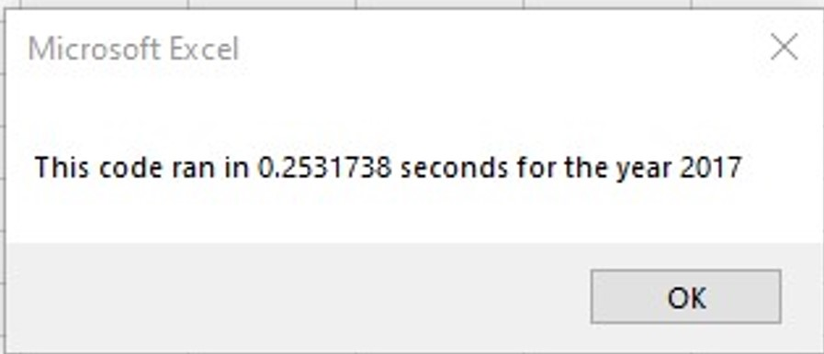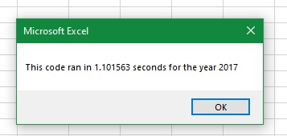

**Before and after refactoring of stock data 2017**

After refactoring

Before refactoring